Project Plan Report
AI-Powered Chatbot Development for Customer Support Automation
Customer-Support Chatbot Pilot for Kestrel Home Co. (KHC)
ITSU2006R – IT Project Management (S2-2026)
Assessment 3 – Group Project Plan Report (Group-20%)
Group Members
No. | Student Name | Student ID | Section Responsible
1 | Ibrahim Fayad Tamim | 69454 | Introduction, Literature Review, Project Charter
2 | Ummey Ayesha | 66226 | WBS, Project Schedule & Gantt Chart, Appendix A
3 | Fuhad Ahammed Shadin | 70227 | Resource Allocation & RASIC, Risk Management, Issue Management
4 | MD Rifat Hasan Rafi | 68031 | Change & Configuration Management, Communication, Quality, Conclusion, Appendices B–C

Group Number | 33 | Campus | Melbourne
Lecturer | Md. Hasin Reza Siddiquei | Group Leader
Due Date | 25 October 2026 | Id: | Name:

Table of Contents
1. Introduction 3
1.1 Background 3
1.2 Problem statement 3
1.3 Purpose and scope of this report 3
2. Literature review 3
2.1 Customer-service chatbots: benefits and adoption 3
2.2 Accuracy and hallucination 4
2.3 Security, privacy and AI governance 4
2.4 Project management approach for AI projects 5
2.5 Gaps and how this plan addresses them 5
3. Project charter 6
3.1 General information 6
3.2 Business case and objectives 6
3.3 Scope statement 7
3.4 Assumptions and constraints 7
3.5 Milestones 8
3.6 Stakeholder register and management strategy 8
3.7 Project organisation, roles and responsibilities 9
3.8 Resources and funding 9
3.9 Business continuity and disaster recovery 10
3.10 Charter approval 10
4. Work breakdown structure 10
5. Project schedule 11
5.1 Scheduling method and estimates 11
5.2 Activity list and dependencies 11
5.3 Gantt chart 14
5.4 Network diagram and critical path 15
5.5 Schedule compression options 16
5.6 Schedule monitoring and control 16
6. Resource allocation and responsibility matrix 16
6.1 Resource plan and cost estimate 16
6.2 RASIC responsibility matrix 17
7. Risk management plan 18
7.1 Approach 18
7.2 Risk register 20
8. Issue management strategy 22
8.1 Issue process 22
9. Change request and configuration management 23
9.1 Change request process 23
9.2 Configuration management with GitHub 24
10. Communication management plan 24
11. Quality management approach 25
12. Conclusion 26
References 28
Appendix A: WBS dictionary 30
Appendix B: Change request form template 31
Appendix C: Collaboration evidence (Jira and GitHub) 32

1. Introduction

1.1 Background
KHC is a hypothetical mid-sized online retailer based in Melbourne that sells furniture and homewares across Australia. Its customer-service team of 22 agents answers email, phone and web-chat contacts during business hours. Ticket data (assumed for this plan) shows that the top ten question types, such as “Where is my order?”, “How do I return an item?” and “How do I reset my password?”, make up most of the volume. Customers who contact KHC after 6 pm wait until the next business day, and peak periods such as end-of-financial-year sales push email response times past 48 hours.

1.2 Problem statement
KHC’s support team spends most of its time answering repetitive questions, so customers wait too long and complex cases get less attention. A chatbot could answer routine questions instantly, 24/7. However, a chatbot that invents a refund policy, shows one customer another customer’s order, or can be tricked into ignoring its rules would create legal, financial and reputational harm.

1.3 Purpose and scope of this report

2. Literature review
The literature was reviewed under four themes: (1) the value and limits of customer-service chatbots, (2) the accuracy problem of generative AI, (3) security, privacy and governance, and (4) project management methods for AI projects. Each theme led directly to a decision in this plan.

2.1 Customer-service chatbots: benefits and adoption
Early work by Xu et al. [3] trained a chatbot on more than one million customer-service conversations from Twitter and found it handled emotional requests nearly as well as human agents but struggled with requests needing specific account information. Følstad and Brandtzaeg [4] argue that chatbots change design from screens to conversations, so the quality of the conversation itself (tone, clarity and when to stop) becomes the product. Adam, Wessel and Benlian [5] ran an online experiment showing that human-like cues and a sense of social presence increase users’ willingness to follow a chatbot’s requests. Taken together, these studies suggest that chatbots can reduce workload, but only when users trust them, and trust depends on answers being correct and on a clear way to reach a person. This plan therefore treats human handoff as a core feature, not an extra (WBS 4.1 and 5.3), and measures customer satisfaction during the pilot (Section 11).

2.2 Accuracy and hallucination
Ji et al. [6] survey “hallucination” in natural-language generation, where a model produces fluent text that is not supported by its source. They show the problem appears across tasks and cannot be removed by model size alone. Lewis et al. [7] proposed retrieval-augmented generation (RAG), where the model retrieves relevant documents and generates its answer from them, which improved factual accuracy on knowledge-intensive tasks. RAG reduces but does not eliminate hallucination, because retrieval can return the wrong document or the model can still go beyond it. The legal risk is real. In Moffatt v.

2.3 Security, privacy and AI governance

2.4 Project management approach for AI projects
The literature does not settle which is better.

2.5 Gaps and how this plan addresses them

Table 1. Traceability from literature to plan decisions.
Finding | Source | Plan decision | Where
Trust depends on correct answers and a route to a human | [3], [5] | Mandatory human handoff; CSAT target | WBS 4.1, 5.3; Sec. 11
LLMs hallucinate; the business is liable | [6], [8] | RAG on approved content; 90% accuracy gate | WBS 3.2, 5.2, 6.2; R01
Prompt injection is the top LLM risk | [9], [10] | Threat model and adversarial test set | WBS 4.3, 6.3; R03
Personal information is protected by APP 6 | [11], [12] | Authenticated lookup; PIA; log redaction | WBS 3.3, 5.4, 5.6; R02
Govern, test, disclose, oversee | [13], [14], [15] | Go/no-go gates; AI disclosure notice | M6, M7; Sec. 11
Accessibility is a legal and quality need | [16] | WCAG 2.2 AA design and test | WBS 4.5, 6.4; R09

3. Project charter

3.1 General information
Table 2. Project charter summary.
Item | Detail
Project title | KHC AI Customer-Support Chatbot (“Ask Kestrel”) – Pilot
Organisation | Kestrel Home Co. (hypothetical), Melbourne, VIC
Project sponsor | Head of Customer Experience, KHC. Owns the business case, approves the charter, budget and go/no-go decisions, and chairs the Change Control Board.
Project manager | MD Rifat Hasan Rafi. Authority to assign team tasks, approve minor changes (Section 9) and spend within the approved baseline.
Start / finish | Mon 1 Feb 2027 – Thu 17 Jun 2027 (95 working days)
Budget | Cost baseline $468,930 (incl. 10% contingency) + $21,315 management reserve held by sponsor
Delivery approach | Hybrid: predictive phases and gates; two-week Agile sprints during Build
Charter version | v1.0, approved at milestone M1 (11 Feb 2027); stored in GitHub, tag v0.1-charter

3.2 Business case and objectives
Assuming 15,000 contacts a month at an average handling cost of $8, and a chatbot that fully resolves 30% of contacts after rollout, KHC would avoid about $36,000 a month ($432,000 a year) in handling cost, with a payback period of about 14 months on the $490,245 total budget. Intangible benefits include 24/7 answers and more agent time for complex cases. These figures are planning assumptions to be confirmed in WBS 1.1.
The project objectives are SMART (specific, measurable, achievable, relevant and time-bound):
- Deliver a tested chatbot that answers KHC’s top 20 routine intents with at least 90% accuracy on a 300-question gold test set by 21 May 2027 (M6).
- Route 100% of sensitive or low-confidence test conversations to a human agent with the chat history attached.
- Run a 10-day controlled pilot on 10% of web-chat traffic that achieves 30% containment (resolved without an agent) and CSAT of at least 4.0/5 by 9 June 2027 (M7).
- Pass go-live with zero open critical or high security findings, zero privacy incidents and no WCAG 2.2 AA failures.
- Finish by 17 June 2027 within the $468,930 cost baseline (±10% control threshold).

3.3 Scope statement
In scope: analysis of support tickets; approval of FAQ content for the top 20 intents; privacy impact assessment; conversation and escalation design; retrieval-based answer generation; authenticated order-status lookup; web chat widget on the KHC website; live-agent handoff; logging with personal-information redaction; system, accuracy, security, accessibility and user acceptance testing; agent training; a controlled pilot; handover to business-as-usual (BAU) support.
Out of scope: refunds, order changes or cancellations; taking payments or card details; legal or product-safety advice; phone/voice channel; languages other than English; social-media channels; full production rollout to 100% of traffic (a separate decision after M7); and use of real customer data by the student project team.
Table 3. Major deliverables and acceptance criteria.
Deliverable | Acceptance criteria | Approver
Project charter & management plan | Signed by sponsor; baselined in GitHub | Sponsor
Requirements & privacy impact assessment | All top-20 intents and data fields listed; PIA actions agreed by Privacy Officer | Sponsor
Approved knowledge content | Each answer has an owner, source policy and review date | Support Content Lead
Solution & security design | Architecture, threat model and API design reviewed; no unresolved high design risks | Project Manager
Working chatbot (pilot release) | All test exit criteria in Section 11 met; tagged release in GitHub | Sponsor (M6)
Pilot evaluation report | Containment, CSAT, accuracy and incident results against targets; rollout recommendation | Sponsor (M7)
Handover pack & closure report | Runbook, support contacts, lessons learned; BAU owner signs acceptance | Sponsor (M8)

3.4 Assumptions and constraints

3.5 Milestones
Table 4. Milestone schedule (all are sponsor or PM decision points).
ID | Milestone | Date | Gate criteria
M1 | Charter approved | 11 Feb 27 | Charter signed; kick-off held
M2 | Project management plan approved | 22 Feb 27 | Plan baselined in GitHub (v0.2-plan)
M3 | Requirements signed off | 12 Mar 27 | Requirements, FAQ content and PIA approved
M4 | Design approved | 30 Mar 27 | Designs approved; threat model complete
M5 | Build complete | 22 Apr 27 | All features merged; build demo accepted
M6 | Go/no-go decision for pilot | 21 May 27 | Test exit criteria met; UAT signed
M7 | Pilot accepted | 09 June 27 | Pilot targets met or accepted with actions
M8 | Project closed (sponsor sign-off) | 17 June 27 | Handover signed; closure report approved

3.6 Stakeholder register and management strategy
Stakeholders were identified during initiation and rated on interest and influence (power).
Table 5. Stakeholder register.
Stakeholder | Role / interest | Interest | Influence | Strategy
Head of Customer Experience | Sponsor; wants lower cost and faster service | High | High | Manage closely: fortnightly steering, gate approvals
Customer Service Team Leader | Support Content Lead; owns answers | High | Medium | Manage closely: weekly reviews, UAT lead
Support agents (22) | Users of handoff; worried about job impact | High | Low | Keep informed: briefings, UAT, training
KHC customers | End users; want fast, correct help | High | Low | Keep informed: AI notice, pilot survey
Privacy Officer | Compliance with Privacy Act/APPs | Medium | High | Keep satisfied: PIA, CCB member
IT Operations Manager | Hosting, security, support after go-live | Medium | High | Keep satisfied: design reviews, CCB member
E-commerce platform team | Provides order API (external dependency) | Medium | Medium | Keep informed: agreed access date
Finance Manager | Budget and benefits tracking | Low | High | Keep satisfied: monthly cost report
AI platform vendor | Supplies model and platform under contract | Medium | Medium | Keep informed: SLA reviews

3.7 Project organisation, roles and responsibilities
Figure 1. Project organisation chart.
Table 6. Roles and responsibilities.
Role | Person | Responsibilities and authority
Project Sponsor | Head of Customer Experience, KHC | Funds the project; approves charter, plan, go/no-go and closure; chairs CCB; holds management reserve.
Project Manager | MD Rifat Hasan Rafi | Plans and controls scope, schedule, cost and quality; runs status and risk reviews; approves minor changes; owns registers and reports.
BA & Security Lead | Ibrahim Fayad Tamim | Gathers requirements and ticket analysis; leads PIA, threat model, security testing and log redaction; stakeholder register.
Technical Lead | Fuhad Ahammed Shadin | Owns architecture, platform, integrations and environments; manages vendor and contract developer; GitHub repository admin.
QA & Conversation Lead | Ummey Ayesha | Designs conversation flows and handoff; owns test strategy, gold test set, accessibility and test reporting.
Support Content Lead | Customer Service Team Leader, KHC | Writes and approves answer content; leads UAT; trains agents; BAU owner after handover.
Change Control Board | Sponsor, PM, IT Ops, Privacy Officer, Finance | Decides major change requests within 5 business days.

3.8 Resources and funding
The project is funded from KHC’s 2026–27 customer-experience budget.

3.9 Business continuity and disaster recovery

3.10 Charter approval
Name / role | Signature | Date
Head of Customer Experience (Sponsor)
MD Rifat Hasan Rafi (Project Manager)
Privacy Officer, KHC

4. Work breakdown structure
The WBS was built top-down by lifecycle phase and checked bottom-up with the team. It follows the 100% rule: every deliverable in the scope statement appears once, and nothing outside scope appears [1]. Level 1 contains eight phases and level 2 contains 34 work packages plus eight milestones. Each work package has one responsible owner, as recommended in Lesson 3, and is described in the WBS dictionary in Appendix A. Project management (status reporting, risk reviews) is a level-of-effort activity that runs across the whole project and is not drawn as a separate box.
Figure 2. Graphical WBS (levels 0–2).

5. Project schedule

5.1 Scheduling method and estimates
The schedule was built using the steps in Lesson 3: sequence the WBS activities, estimate durations, draw the network diagram, find the critical path and chart the result [2]. Durations are in working days (Monday–Friday, 7.6-hour days). Victorian public holidays in the period are excluded: Labour Day (8 Mar), Good Friday (26 Mar), Easter Monday (29 Mar) and the King’s Birthday (14 Jun 2027). Most durations use expert judgement from the team and analogous estimates. The five most uncertain activities use three-point PERT estimates, where expected time = (O + 4M + P) / 6 and standard deviation = (P − O) / 6.
Table 7. PERT estimates for high-uncertainty activities (days).
ID | Activity | Optimistic (O) | Most likely (M) | Pessimistic (P) | Expected TE | Std dev σ | Used
3.2 | FAQ content review | 5 | 8 | 13 | 8.33 | 1.33 | 8
5.3 | Conversation flows & handoff | 7 | 10 | 15 | 10.33 | 1.33 | 10
5.4 | Order-status integration | 6 | 8 | 12 | 8.33 | 1.00 | 8
6.3 | Security testing | 4 | 6 | 9 | 6.17 | 0.83 | 6
4.1 | Conversation design | 4 | 6 | 8 | 6.00 | 0.67 | 6
Because 3.2, 5.4, 6.3 and 4.1 are on the critical path, their combined standard deviation (√(1.33² + 1.00² + 0.83² + 0.67²) ≈ 2.0 days) indicates roughly an 84% chance of finishing within about 2 days of plan. This risk is covered by the contingency actions in Section 5.5 rather than padding every task.

5.2 Activity list and dependencies
Table 8 lists every activity with its duration, predecessors, early and late dates and total float. All links are finish-to-start (FS). Dependency types follow Lesson 5: mandatory (e.g. testing cannot start before the build is complete, 6.1 after M5), discretionary (e.g. starting accessible UI design 4.5 after the conversation flow 4.1 is best practice but not physically required) and external (e.g. 5.4 depends on the e-commerce platform team granting API access, risk R11).
Table 8. Activity list with critical path analysis (ES/EF/LS/LF are working-day numbers; CP = critical path).
ID | Activity | Dur | Pred. | Owner | Start | Finish | Float | CP
1.1 | Business case & feasibility review | 3 | – | Project Manager | 01 Feb 27 | 03 Feb 27 | 0 | Yes
1.2 | Develop project charter | 3 | 1.1 | Project Manager | 04 Feb 27 | 08 Feb 27 | 0 | Yes
1.3 | Stakeholder register & engagement strategy | 2 | 1.2 | BA/Sec Lead | 09 Feb 27 | 10 Feb 27 | 0 | Yes
1.4 | Kick-off meeting | 1 | 1.3 | Project Manager | 11 Feb 27 | 11 Feb 27 | 0 | Yes
M1 | Charter approved | 0 | 1.4 | Sponsor | 11 Feb 27 | 11 Feb 27 | 0 | Yes
2.1 | WBS & WBS dictionary | 3 | M1 | Project Manager | 12 Feb 27 | 16 Feb 27 | 0 | Yes
2.2 | Schedule & cost baseline | 3 | 2.1 | Project Manager | 17 Feb 27 | 19 Feb 27 | 1
2.3 | Risk, quality, comms & change plans | 4 | 2.1 | Project Manager | 17 Feb 27 | 22 Feb 27 | 0 | Yes
2.4 | Set up Jira board & GitHub repository | 2 | 2.1 | Technical Lead | 17 Feb 27 | 18 Feb 27 | 2
M2 | Project management plan approved | 0 | 2.2, 2.3, 2.4 | Sponsor | 22 Feb 27 | 22 Feb 27 | 0 | Yes
3.1 | Analyse support tickets & rank top intents | 5 | M2 | BA/Sec Lead | 23 Feb 27 | 01 Mar 27 | 0 | Yes
3.2 | Review & approve FAQ knowledge content | 8 | 3.1 | Support Lead | 02 Mar 27 | 12 Mar 27 | 0 | Yes
3.3 | Privacy impact assessment & data map | 5 | 3.1 | BA/Sec Lead | 02 Mar 27 | 09 Mar 27 | 3
3.4 | Functional & non-functional requirements | 4 | 3.1 | BA/Sec Lead | 02 Mar 27 | 05 Mar 27 | 4
M3 | Requirements signed off | 0 | 3.2, 3.3, 3.4 | Sponsor | 12 Mar 27 | 12 Mar 27 | 0 | Yes
4.1 | Conversation flow & human-handoff design | 6 | M3 | QA Lead | 15 Mar 27 | 22 Mar 27 | 0 | Yes
4.2 | Solution architecture & retrieval (RAG) design | 5 | M3 | Technical Lead | 15 Mar 27 | 19 Mar 27 | 1
4.3 | Security design & threat model | 4 | 4.2 | BA/Sec Lead | 22 Mar 27 | 25 Mar 27 | 1
4.4 | Order-status API integration design | 4 | 4.2 | Technical Lead | 22 Mar 27 | 25 Mar 27 | 1
4.5 | Accessible chat UI design (WCAG 2.2) | 4 | 4.1 | QA Lead | 23 Mar 27 | 30 Mar 27 | 0 | Yes
M4 | Design approved | 0 | 4.3, 4.4, 4.5 | Sponsor | 30 Mar 27 | 30 Mar 27 | 0 | Yes
5.1 | Configure platform & environments | 4 | M4 | Technical Lead | 31 Mar 27 | 05 Apr 27 | 0 | Yes
5.2 | Knowledge-base ingestion & retrieval | 8 | 5.1 | Technical Lead | 06 Apr 27 | 15 Apr 27 | 5
5.3 | Conversation flows & live-agent handoff | 10 | 5.1 | QA Lead | 06 Apr 27 | 19 Apr 27 | 3
5.4 | Authenticated order-status integration | 8 | 5.1 | Technical Lead | 06 Apr 27 | 15 Apr 27 | 0 | Yes
5.5 | Web chat widget | 6 | 5.1 | Technical Lead | 06 Apr 27 | 13 Apr 27 | 7
5.6 | Logging, monitoring & PII redaction | 5 | 5.4 | BA/Sec Lead | 16 Apr 27 | 22 Apr 27 | 0 | Yes
M5 | Build complete | 0 | 5.2, 5.3, 5.5, 5.6 | Project Manager | 22 Apr 27 | 22 Apr 27 | 0 | Yes
6.1 | System & integration testing | 6 | M5 | QA Lead | 23 Apr 27 | 30 Apr 27 | 0 | Yes
6.2 | Answer-accuracy testing (gold set) | 5 | M5 | QA Lead | 23 Apr 27 | 29 Apr 27 | 7
6.3 | Security testing (prompt injection, pen test) | 6 | 6.1 | BA/Sec Lead | 03 May 27 | 10 May 27 | 0 | Yes
6.4 | Accessibility testing | 3 | 6.1 | QA Lead | 03 May 27 | 05 May 27 | 3
6.5 | User acceptance testing | 5 | 6.2, 6.3, 6.4 | Support Lead | 11 May 27 | 17 May 27 | 0 | Yes
6.6 | Defect fixing & regression test | 4 | 6.5 | Technical Lead | 18 May 27 | 21 May 27 | 0 | Yes
M6 | Go/no-go decision for pilot | 0 | 6.6 | Sponsor | 21 May 27 | 21 May 27 | 0 | Yes
7.1 | Train support agents | 3 | 6.5 | Support Lead | 18 May 27 | 20 May 27 | 1
7.2 | Controlled pilot (10% of web chats) | 10 | M6, 7.1 | Project Manager | 24 May 27 | 04 June 27 | 0 | Yes
7.3 | Pilot evaluation & rollout recommendation | 3 | 7.2 | Project Manager | 07 June 27 | 09 June 27 | 0 | Yes
M7 | Pilot accepted | 0 | 7.3 | Sponsor | 09 June 27 | 09 June 27 | 0 | Yes
8.1 | Handover to BAU support & documentation | 3 | M7 | Technical Lead | 10 June 27 | 15 June 27 | 0 | Yes
8.2 | Lessons learned & closure report | 2 | 8.1 | Project Manager | 16 June 27 | 17 June 27 | 0 | Yes
M8 | Project closed (sponsor sign-off) | 0 | 8.2 | Sponsor | 17 June 27 | 17 June 27 | 0 | Yes

5.3 Gantt chart
Figure 3. Gantt chart showing phases, activities, milestones, finish-to-start dependencies, total float and the critical path (red).

5.4 Network diagram and critical path
Figure 4. Precedence diagram (activity-on-node). Each box shows ES | ID | EF on top and LS | duration, float | LF below; red boxes and thick arrows are critical.
The forward and backward pass give a project duration of 95 working days. The critical path (zero total float) is:

5.5 Schedule compression options

Table 9. Schedule compression options.
Option | Technique | Days saved | Cost / risk
Start 4.1 conversation design on approved FAQ batches before all of 3.2 is complete | Fast-tracking (overlap up to ~33%) | Up to 3 | No cost; rework risk if content changes
Add the contract developer to 5.4 order-status integration | Crashing | 2–3 | ~$900/day; extra code-review effort
Run 6.4 accessibility testing alongside 6.3 with an external auditor | Fast-tracking | 0 (already off path) | Protects float only
Shorten pilot 7.2 from 10 to 7 days | Scope/quality trade-off (CR needed) | 3 | Less pilot data; needs CCB approval

5.6 Schedule monitoring and control

6. Resource allocation and responsibility matrix

6.1 Resource plan and cost estimate
Labour was estimated bottom-up from the schedule: each role is assigned for the phases it works on, multiplied by a loaded daily rate. Non-labour costs come from indicative vendor quotes. Following Lesson 4, a contingency reserve of 10% covers known risks (e.g. R05, R11, R12) and sits inside the cost baseline, while a management reserve of 5% covers unknown risks and is held by the sponsor.
Table 10. Labour resources and cost.
Role | Allocation | When | Days | Rate/day | Cost
Project Manager | 100% | Whole project (1.1–8.2) | 95 | $950 | $90,250
BA & Security Lead | 100% | 1.3 to 8.1 | 90 | $900 | $81,000
Technical Lead | 100% | Planning (2.1) to closure | 79 | $1,000 | $79,000
QA & Conversation Lead | 100% | Planning (2.1) to pilot end | 74 | $850 | $62,900
Support Content Lead (KHC) | ~50% | 3.2, 4.1 review, 6.5, 7.1, 7.2 | 30 | $600 | $18,000
Contract developer | 100% | Build and defect fixing (5.1–6.6) | 38 | $900 | $34,200
Contract tester | 100% | Testing (6.1–6.6) | 21 | $750 | $15,750
Labour subtotal |  |  |  |  | $381,100
Table 11. Budget summary.
Cost item | Amount
Labour (Table 10) | $381,100
AI platform licence and usage (5 months) | $15,000
Cloud hosting – dev, test, pilot | $6,000
Independent penetration test | $15,000
External accessibility audit | $6,000
Jira and GitHub licences | $1,200
Training materials | $2,000
Direct cost total | $426,300
Contingency reserve (10%) | $42,630
Cost baseline (BAC) | $468,930
Management reserve (5%, held by sponsor) | $21,315
Total project budget | $490,245

6.2 RASIC responsibility matrix
Table 12 uses the RASIC format from Lesson 6: R = Responsible (does the work; only one per deliverable), A = Approves (accountable), S = Supports, I = Informed, C = Consulted. Following the Lesson 6 rules, deliverables are approved by the PM before they go to the sponsor, and peers support but do not share responsibility.
Table 12. RASIC matrix for key deliverables.
Deliverable | Sponsor | PM  (Rifat) | BA/Sec  (Ibrahim) | Tech  (Fuhad) | QA  (Ummey) | Support  Lead | Privacy  Officer
Project charter | A | R | S | C | C | C | I
Project management plan | A | R | S | S | S | I | I
Requirements specification | I | A | R | C | S | C | C
Approved FAQ content | I | A | C | I | S | R | I
Privacy impact assessment | I | A | R | S | I | I | C
Solution architecture | I | A | S | R | C | I | I
Security design & threat model | I | A | R | S | C | I | C
Conversation & handoff design | I | A | C | C | R | S | I
Chatbot build & integrations | I | A | S | R | S | I | I
Test plan & test results | I | A | S | S | R | C | I
UAT sign-off | A | C | S | S | S | R | I
Go/no-go & pilot report | A | R | S | S | S | C | C
Change requests (major) | A | R | C | C | C | C | C
Handover & closure report | A | R | S | S | S | C | I

7. Risk management plan

7.1 Approach
A risk is a problem that could happen and would affect time, cost, scope or quality (Lesson 7). The process follows the NIST Map–Measure–Manage cycle [13] and PMBOK guidance [1]:
- Identify: brainstorming at kick-off, a checklist from the OWASP LLM Top 10 [9], lessons from similar projects and the assumptions in Section 3.4.
- Analyse: score likelihood (1 Rare – 5 Almost certain) and impact (1 Negligible – 5 Severe) using Table 13; score = L × I.
- Respond: choose a threat response from Lesson 7 (Prevent, Mitigate, Transfer, Contingency, Accept), name an owner, and define a trigger and a contingency plan.
- Monitor: the PM reviews the register weekly; extreme and high risks are reviewed at every steering meeting; risk owners check triggers; closed risks stay in the register for lessons learned.
Table 13. Impact scale definitions.
Score | Schedule | Cost | Quality / compliance
1 Negligible | < 1 day | < $2k | Cosmetic issue
2 Minor | 1–3 days, within float | $2k–$10k | Minor defect, workaround exists
3 Moderate | Delays a milestone < 1 week | $10k–$25k | Feature degraded; some customer impact
4 Major | Delays a milestone 1–3 weeks | $25k–$50k | Wrong advice to customers; complaint risk
5 Severe | > 3 weeks or misses June deadline | > $50k | Privacy breach, regulator involvement
Figure 5. Risk heat map (likelihood × impact) showing where each register risk sits before treatment.
Two risks are rated extreme: wrong answers (R01, score 16) and privacy disclosure (R02, 15). Four are rated high: prompt injection (R03), reviewer availability (R05), scope creep (R06) and API access delays (R11). The full register is in Table 14.

7.2 Risk register
Table 14. Risk register (L = likelihood, I = impact, S = score).
ID | Risk | Category | L | I | S | Response | Mitigation / actions | Contingency plan | Trigger | Owner
R01 | Chatbot gives an incorrect or invented answer (hallucination) about returns, refunds or delivery | Quality | 4 | 4 | 16 | Mitigate | Answer only from approved knowledge content using retrieval; show the source page; low-confidence answers go to an agent; 90% accuracy gate on gold question set before pilot | Switch the affected intent off; route it to agents; contact affected customers and honour the stated policy | Gold-set accuracy below 90%, or 2+ complaints in a week about wrong advice | QA & Conversation Lead
R02 | Personal order information disclosed to the wrong person | Privacy / security | 3 | 5 | 15 | Prevent | Order lookup only after account login; minimum data fields; PII redaction in logs; privacy impact assessment signed off at M3 | Run data breach response plan; assess under the Notifiable Data Breaches scheme; suspend order lookup | Any test or pilot log showing another customer's data | BA & Security Lead
R03 | Prompt injection or jailbreak makes the bot ignore its rules or reveal system data | Security | 3 | 4 | 12 | Mitigate | Separate system instructions from user text; output filtering; no secrets in prompts; least-privilege API keys; adversarial test set in 6.3 | Block the pattern; roll back to last approved configuration (Git tag); re-test | Any successful injection in security testing or pilot monitoring | BA & Security Lead
R04 | Order-status API is slow, unavailable or returns stale data | Technical | 3 | 3 | 9 | Mitigate | Timeouts and fallback message; show 'last updated' time; monitoring alerts | Hand the chat to an agent with the order number pre-filled | API error rate over 2% or response over 3 s | Technical Lead
R05 | Support team leaders not available to review FAQ content (activity 3.2 is on the critical path) | Resource / schedule | 4 | 3 | 12 | Mitigate | Book reviewer time at kick-off; agree content owner in charter; review in batches tracked in Jira | Sponsor approves backfill for a team leader; fast-track 4.1 to start on approved batches | Review more than 2 days behind plan | Project Manager
R06 | Scope creep (e.g. refunds, order changes, more languages) added without approval | Scope | 4 | 3 | 12 | Prevent | Signed scope baseline; all changes through change request process (Section 8); out-of-scope list in charter | Defer the request to a phase-2 backlog | Work found in Jira not linked to a WBS item or approved CR | Project Manager
R07 | AI platform vendor changes pricing, model version or has an outage | External / vendor | 2 | 4 | 8 | Transfer | Contract with SLA, model-version pinning and notice period for changes | Fall back to search-based FAQ answers; regression-test any new model version | Vendor change notice or outage over 1 hour | Technical Lead
R08 | Customers do not use or trust the chatbot (low adoption) | Business | 3 | 3 | 9 | Mitigate | Clear 'talk to a person' option; short, plain answers; pilot survey; fix top failed intents weekly | Re-design entry point and greeting; extend pilot by one week | Containment rate below 20% or CSAT below 3.8/5 in pilot | QA & Conversation Lead
R09 | Chat widget fails accessibility requirements (WCAG 2.2 AA) | Compliance | 2 | 4 | 8 | Prevent | Accessible design in 4.5; keyboard and screen-reader testing in 6.4; external audit | Delay pilot for the widget only; offer phone and email links | Any AA failure in 6.4 | QA & Conversation Lead
R10 | Loss of a key team member (e.g. Technical Lead) | Resource | 2 | 4 | 8 | Mitigate | Pair work, documentation in GitHub, code review so two people know each component | Use contract developer from the vendor panel | Unplanned absence over 3 days | Project Manager
R11 | E-commerce platform team cannot provide API access in time (external dependency) | External / schedule | 3 | 4 | 12 | Mitigate | Raise access request in week 3; agree date in writing; build against a mock API | Pilot FAQ intents first and add order status as a follow-up release (CR) | Access not granted by start of 5.1 | Technical Lead
R12 | AI usage costs higher than estimated | Cost | 2 | 3 | 6 | Mitigate | Usage caps and alerts; cache common answers; weekly cost report (CPI) | Draw on contingency reserve; reduce pilot traffic share | Monthly AI cost over 110% of budget | Project Manager
R13 | Support agents resist the change or fear job loss | People | 3 | 2 | 6 | Mitigate | Involve agents in content review and UAT; message that bot handles routine questions only | Extra briefing by sponsor; adjust handoff process with agents' input | Negative feedback in agent survey | Support Content Lead
R14 | New Australian AI or privacy rules change requirements during the project | Regulatory | 2 | 3 | 6 | Accept | Monitor OAIC and DISR guidance monthly; design already follows voluntary AI safety standard | Raise a change request if a new rule applies | New guidance published | BA & Security Lead
Opportunity O1 (response: Exploit).

8. Issue management strategy
An issue is a problem that has happened, or an open question that must be decided before work can continue (Lesson 7). Risks become issues when their trigger fires. All issues are logged as “Issue” tickets in Jira and exported weekly to the issue register in GitHub (registers/issue-register.csv).

8.1 Issue process
- Log: anyone raises an issue in Jira with a description, date, impact and suggested owner.
- Assess and prioritise: the PM sets the priority using Table 15 within one business day.

Table 15. Issue priority and escalation rules.
Priority | Definition | Escalation path and timing
Critical | Privacy or security incident, customer harm, or blocks a milestone | Sponsor and Privacy Officer within 1 hour; affected gate stops until resolved
High | Threatens critical path or > $5k | PM within 1 business day; sponsor at next steering meeting
Medium | Affects a non-critical task, within float | Owner resolves; PM reviews weekly
Low | Minor, no schedule or cost effect | Owner resolves; noted in weekly report
Table 16. Issue register template (with example entries showing how it will be used).
ID | Date | Issue | Priority | Owner | Action | Status / link
I-01 | (example) | Ticket export from helpdesk is missing the “category” field, delaying 3.1 | High | BA & Security Lead | Request field from helpdesk admin; classify sample manually | Open
I-02 | (example) | Test-environment API key expired; integration tests blocked | Medium | Technical Lead | Rotate key in secrets vault; add expiry alert | Closed
I-03 | (example) | Marketing asks bot to promote sale items | Medium | Project Manager | Out of scope; raise CR-01 for CCB | Linked CR-01

9. Change request and configuration management

9.1 Change request process
Once the charter, WBS, schedule and budget are approved at M2 they form the baseline, which is tagged in GitHub. Any change to scope, schedule, cost, quality targets or the use of personal data must go through the process in Figure 6. Following Lesson 7, each request answers: What is the change? How will cost, scope, schedule and quality change? What risks are introduced or removed? What are the benefits?
Figure 6. Change request workflow.
Table 17. Change approval authority.
Class | Criteria (any one) | Approver | Decision time
Minor | ≤ 3 days on a non-critical task (within float); ≤ $5,000; no change to deliverables or acceptance criteria | Project Manager | 2 business days
Major | Moves a milestone or the critical path; > $5,000; changes scope, acceptance criteria or personal data use | Change Control Board (chaired by sponsor) | 5 business days
Emergency | Urgent security or privacy fix during test or pilot | PM + BA & Security Lead immediately; CCB reviews afterwards | Same day
Each request is recorded on a change request form (Appendix B) and in the change log. Approved changes are made through a GitHub pull request that updates the affected baseline documents, and the new baseline gets a new version tag.
Table 18. Change log with illustrative entries.
CR | Change requested | Impact assessment | Class | Decision
CR-01 | Add Vietnamese and Mandarin answers (Marketing) | +15 days on critical path, +$22,000, new translation-accuracy risk | Major | Deferred to phase 2 by CCB
CR-02 | Let the bot issue return labels and refunds | Adds financial authorisation and fraud risk; outside charter scope | Major | Rejected; separate business case suggested
CR-03 | Show “last updated” time on order status (from risk R04) | +1 day on 5.5, which has 7 days float; no cost | Minor | Approved by PM; baseline v0.5.1

9.2 Configuration management with GitHub

- A README explains the structure and the current baseline version.

10. Communication management plan
The communication plan makes sure each stakeholder in Table 5 gets the right information at the right time and in the right format. Urgent privacy or security problems are never held for the next meeting.
Table 19. Communication matrix.
Communication | Purpose | Audience | Owner | Frequency | Channel
Kick-off meeting | Review charter, roles, next steps | All stakeholders | PM | Once (1.4) | In person + Teams
Daily stand-up | Progress, plans, blockers | Project team | PM / QA Lead | Daily (Build & Test) | 15 min, Jira board
Weekly status report | RAG status, SPI/CPI, top risks and issues | Sponsor, team, Support Lead | PM | Weekly (Fri) | Email + Confluence page
Steering meeting | Decisions, gate reviews, escalations | Sponsor, PM, IT Ops, Privacy | PM | Fortnightly + at milestones | Meeting, minutes in GitHub
Risk & issue review | Update registers, check triggers | Project team | PM | Weekly | Meeting + Jira
Sprint review / retrospective | Demo build; improve process | Team, Support Lead | Tech Lead | Every 2 weeks (Build) | Meeting
Change Control Board | Decide major CRs | CCB members | PM | As needed (≤ 5 days) | Meeting / email vote
Agent briefing & training | Explain bot and handoff | Support agents | Support Lead | Before pilot (7.1) | Workshop
Customer notice & survey | AI disclosure; collect CSAT | Pilot customers | QA Lead | During pilot | Chat widget
Incident escalation | Privacy or security event | Sponsor, Privacy Officer, IT Ops | BA & Security Lead | Immediately (≤ 1 h) | Phone + email
Closure report | Results, lessons learned | All stakeholders | PM | Once (8.2) | Report + meeting

11. Quality management approach
Quality means the chatbot meets its requirements and is fit for customers to use [1]. The plan separates quality assurance (checking that the process is followed, e.g. peer review of every document by pull request and a gate review at each milestone) from quality control (measuring the product against targets). The quality standards are WCAG 2.2 AA [16], the APPs [12], the OWASP LLM Top 10 [9], the guardrails of the Voluntary AI Safety Standard [14] and KHC’s customer-service style guide.
Table 20. Quality metrics and acceptance targets.
Metric | Target | How measured | When | Owner
Answer accuracy | ≥ 90% correct on 300-question gold set | Blind review by Support Lead and QA | 6.2, repeated weekly in pilot | QA Lead
Correct escalation | 100% of sensitive/uncertain test cases go to an agent | Scripted test cases | 6.1, 6.5 | QA Lead
Security | 0 open critical/high findings | Prompt-injection tests + external pen test | 6.3 | BA & Security Lead
Privacy | 0 personal data in logs or prompts | Log sampling and automated scan | 6.3, pilot | BA & Security Lead
Accessibility | 0 WCAG 2.2 AA failures | Keyboard, screen-reader and audit | 6.4 | QA Lead
Performance | 95% of replies in ≤ 3 seconds | Monitoring dashboard | 6.1, pilot | Technical Lead
UAT | ≥ 95% test cases pass; no severity-1 defects | UAT scripts | 6.5 | Support Lead
Pilot outcome | ≥ 30% containment; CSAT ≥ 4.0/5 | Chat analytics + survey | 7.2–7.3 | PM
Document quality | Every baseline document reviewed by one other member | GitHub pull request approvals | Ongoing | PM

12. Conclusion
This report has planned KHC’s AI customer-support chatbot as a controlled, 20-week pilot rather than a technology experiment. The literature showed that chatbots save effort only when customers trust them, and that the main threats to trust (hallucination, prompt injection and privacy leaks) are well documented and, as Moffatt v. Air Canada shows, carry real liability.
The charter defines SMART objectives, clear scope boundaries, nine stakeholder groups and named roles. The WBS breaks the work into 34 owned work packages.

References
[1] Project Management Institute, A Guide to the Project Management Body of Knowledge (PMBOK Guide), 7th ed. Newtown Square, PA, USA: PMI, 2021.
[2] K. Schwalbe, Information Technology Project Management, 9th ed. Boston, MA, USA: Cengage Learning, 2019.
[3] A. Xu, Z. Liu, Y. Guo, V. Sinha, and R. Akkiraju, “A new chatbot for customer service on social media,” in Proc. CHI Conf. Human Factors Comput. Syst., Denver, CO, USA, 2017, pp. 3506–3510, doi: 10.1145/3025453.3025496.
[4] A. Følstad and P. B. Brandtzaeg, “Chatbots and the new world of HCI,” Interactions, vol. 24, no. 4, pp. 38–42, 2017, doi: 10.1145/3085558.
[5] M. Adam, M. Wessel, and A. Benlian, “AI-based chatbots in customer service and their effects on user compliance,” Electronic Markets, vol. 31, no. 2, pp. 427–445, 2021, doi: 10.1007/s12525-020-00414-7.
[6] Z. Ji et al., “Survey of hallucination in natural language generation,” ACM Comput. Surv., vol. 55, no. 12, Art. no. 248, 2023, doi: 10.1145/3571730.
[7] P. Lewis et al., “Retrieval-augmented generation for knowledge-intensive NLP tasks,” in Proc. Adv. Neural Inf. Process. Syst. (NeurIPS), vol. 33, 2020, pp. 9459–9474.
[8] Moffatt v. Air Canada, 2024 BCCRT 149, Civil Resolution Tribunal of British Columbia, Feb. 14, 2024.
[9] OWASP Foundation, “OWASP Top 10 for LLM Applications 2025,” OWASP GenAI Security Project, Nov. 2024. Accessed: Oct. 25, 2026. [Online]. Available: https://genai.owasp.org/llm-top-10/
[10] K. Greshake, S. Abdelnabi, S. Mishra, C. Endres, T. Holz, and M. Fritz, “Not what you’ve signed up for: Compromising real-world LLM-integrated applications with indirect prompt injection,” in Proc. 16th ACM Workshop Artif. Intell. Secur. (AISec ’23), Copenhagen, Denmark, 2023, pp. 79–90, doi: 10.1145/3605764.3623985.
[11] Privacy Act 1988 (Cth). Accessed: Oct. 25, 2026. [Online]. Available: https://www.legislation.gov.au/C2004A03712/latest
[12] Office of the Australian Information Commissioner, “Chapter 6: APP 6 Use or disclosure of personal information,” Australian Privacy Principles Guidelines. Accessed: Oct. 25, 2026. [Online]. Available: https://www.oaic.gov.au/privacy/australian-privacy-principles/australian-privacy-principles-guidelines/chapter-6-app-6-use-or-disclosure-of-personal-information
[13] National Institute of Standards and Technology, “Artificial Intelligence Risk Management Framework (AI RMF 1.0),” NIST, Gaithersburg, MD, USA, NIST AI 100-1, 2023, doi: 10.6028/NIST.AI.100-1.
[14] Department of Industry, Science and Resources, “Voluntary AI Safety Standard,” Australian Government, Canberra, ACT, Australia, Sep. 2024. Accessed: Oct. 25, 2026. [Online]. Available: https://www.industry.gov.au/publications/voluntary-ai-safety-standard
[15] Information Technology — Artificial Intelligence — Management System, ISO/IEC 42001:2023, International Organization for Standardization, Geneva, Switzerland, 2023.
[16] World Wide Web Consortium, “Web Content Accessibility Guidelines (WCAG) 2.2,” W3C Recommendation, Oct. 5, 2023. Accessed: Oct. 25, 2026. [Online]. Available: https://www.w3.org/TR/WCAG22/
[17] K. Schwaber and J. Sutherland, “The Scrum Guide,” Nov. 2020. Accessed: Oct. 25, 2026. [Online]. Available: https://scrumguides.org/scrum-guide.html
[18] GitHub, “About protected branches,” GitHub Docs. Accessed: Oct. 25, 2026. [Online]. Available: https://docs.github.com/en/repositories/configuring-branches-and-merges-in-your-repository/managing-protected-branches/about-protected-branches

Appendix A: WBS dictionary
Each work package has one owner, a description of the work, its output and its acceptance check (format based on the Lesson 3 WBS dictionary entry).
ID | Work package | Description of work | Output / acceptance | Owner | Days
1.1 | Business case & feasibility review | Confirm problem, benefits, costs and feasibility with sponsor | Business case v1.0 | Project Manager | 3
1.2 | Develop project charter | Draft objectives, scope, milestones, roles and budget | Signed charter | Project Manager | 3
1.3 | Stakeholder register & engagement strategy | Identify stakeholders; rate interest and influence; set strategy | Stakeholder register | BA & Security Lead | 2
1.4 | Kick-off meeting | Present charter, roles and next steps to all stakeholders | Kick-off minutes | Project Manager | 1
2.1 | WBS & WBS dictionary | Decompose scope into work packages; write dictionary | WBS + dictionary | Project Manager | 3
2.2 | Schedule & cost baseline | Estimate durations and costs; find critical path | Schedule & cost baseline | Project Manager | 3
2.3 | Risk, quality, comms & change plans | Write risk, quality, communication and change plans | Subsidiary plans | Project Manager | 4
2.4 | Set up Jira board & GitHub repository | Create Jira project, epics, workflow and GitHub repository | Configured tools | Technical Lead | 2
3.1 | Analyse support tickets & rank top intents | Classify 12 months of anonymised tickets; rank top 20 intents | Ranked intent list | BA & Security Lead | 5
3.2 | Review & approve FAQ knowledge content | Write/approve answer content for each intent | Approved knowledge base | Support Content Lead | 8
3.3 | Privacy impact assessment & data map | Map personal data flows; assess APP compliance; agree actions | PIA report | BA & Security Lead | 5
3.4 | Functional & non-functional requirements | Document functional and non-functional requirements | Requirements spec | BA & Security Lead | 4
4.1 | Conversation flow & human-handoff design | Design dialogue, fallbacks and handoff rules | Conversation flow diagrams | QA & Conversation Lead | 6
4.2 | Solution architecture & retrieval (RAG) design | Design platform, retrieval pipeline and environments | Architecture document | Technical Lead | 5
4.3 | Security design & threat model | Threat model using OWASP LLM Top 10; define controls | Threat model | BA & Security Lead | 4
4.4 | Order-status API integration design | Design authenticated order-status API calls and error handling | Integration design | Technical Lead | 4
4.5 | Accessible chat UI design (WCAG 2.2) | Design accessible widget (keyboard, focus, contrast, screen reader) | UI design + checklist | QA & Conversation Lead | 4
5.1 | Configure platform & environments | Set up dev/test/pilot environments and access control | Working environments | Technical Lead | 4
5.2 | Knowledge-base ingestion & retrieval | Load approved content; tune retrieval and answer prompts | Retrieval component | Technical Lead | 8
5.3 | Conversation flows & live-agent handoff | Build dialogues and live-agent transfer with history | Conversation flows in platform | QA & Conversation Lead | 10
5.4 | Authenticated order-status integration | Build login check and order-status API calls | Integration component | Technical Lead | 8
5.5 | Web chat widget | Build and embed chat widget on website | Chat widget | Technical Lead | 6
5.6 | Logging, monitoring & PII redaction | Add monitoring, alerting and PII redaction to logs | Monitoring + redaction | BA & Security Lead | 5
6.1 | System & integration testing | Run system and integration test cases | Test report | QA & Conversation Lead | 6
6.2 | Answer-accuracy testing (gold set) | Run 300-question gold set; blind-score answers | Accuracy report | QA & Conversation Lead | 5
6.3 | Security testing (prompt injection, pen test) | Prompt-injection tests and external penetration test | Security test report | BA & Security Lead | 6
6.4 | Accessibility testing | Keyboard, screen-reader and WCAG 2.2 AA audit | Accessibility report | QA & Conversation Lead | 3
6.5 | User acceptance testing | Support team runs UAT scripts | Signed UAT | Support Content Lead | 5
6.6 | Defect fixing & regression test | Fix defects; run regression tests | Release candidate tag | Technical Lead | 4
7.1 | Train support agents | Train agents on handoff and escalation | Trained agents | Support Content Lead | 3
7.2 | Controlled pilot (10% of web chats) | Run bot on 10% of web chats; monitor daily | Pilot data | Project Manager | 10
7.3 | Pilot evaluation & rollout recommendation | Analyse pilot results; recommend rollout decision | Pilot evaluation report | Project Manager | 3
8.1 | Handover to BAU support & documentation | Hand over runbook, content ownership and support to BAU | Signed handover | Technical Lead | 3
8.2 | Lessons learned & closure report | Run lessons-learned session; write closure report | Closure report | Project Manager | 2

Appendix B: Change request form template
Field | Entry
CR number / date | CR-__ / __/__/2027
Requested by (name, role)
Description of change
Reason / benefit
Affected deliverables / WBS IDs
Schedule impact (days; critical path Y/N)
Cost impact ($)
Scope and quality impact
Risks introduced or reduced
Class (Minor / Major / Emergency)
Recommendation (PM)
Decision (Approved / Rejected / Deferred) and approver
Baseline version updated / GitHub PR link
Communicated to

Appendix C: Collaboration evidence (Jira and GitHub)
[Insert before submission. Screenshots must be of the group’s real Jira board and GitHub repository.]
[ Figure C1: Jira board showing epics (WBS phases), stories, owners and status ]
[ Figure C2: Jira issue/risk/change request tickets ]
[ Figure C3: GitHub repository structure and README ]
[ Figure C4: GitHub commit history showing commits from all four members ]
[ Figure C5: A reviewed and merged pull request ]
[ Figure C6: GitHub tags/releases for baselines ]
Repository URL: ______________________________ Submitted version (tag/commit): ______________

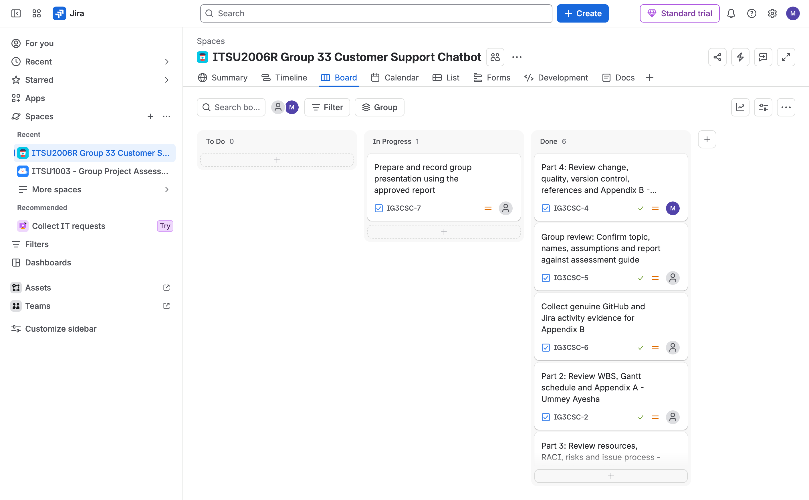
Figure C1: Jira board showing project tasks and current status.
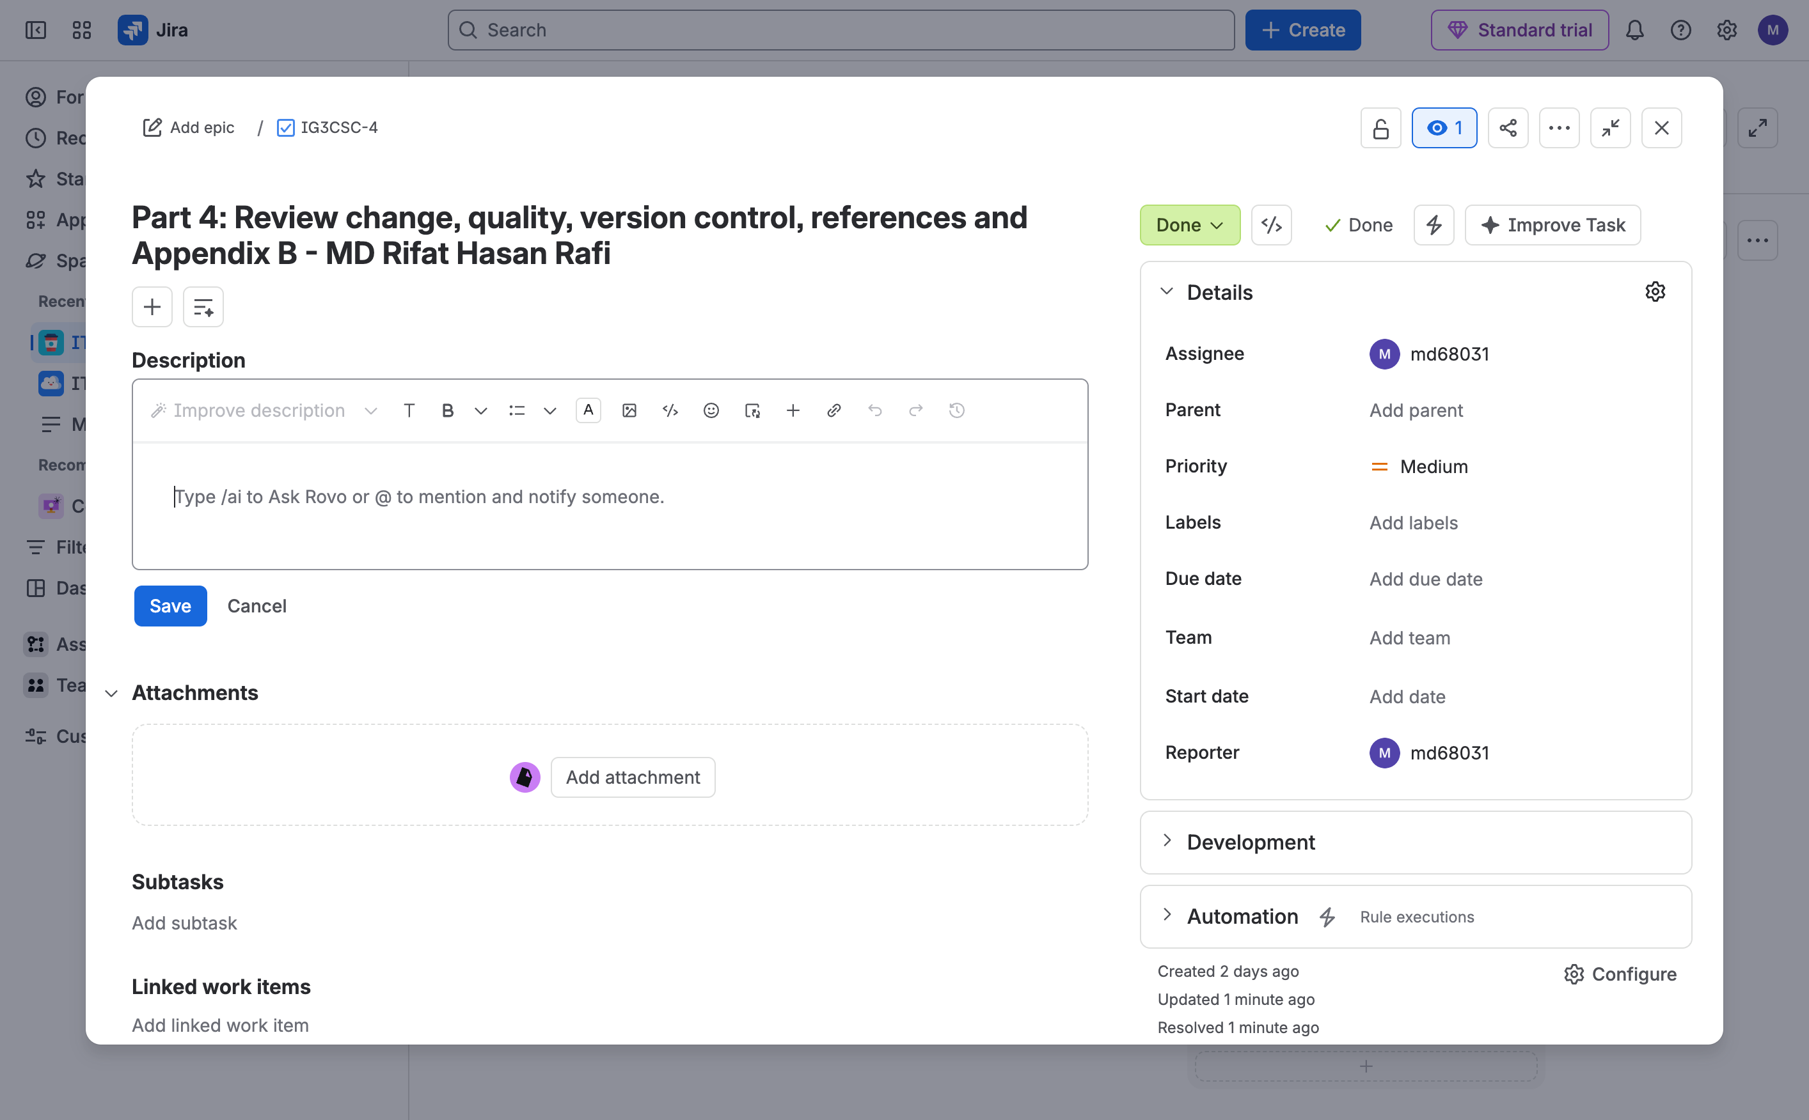
Figure C2: Jira task assigned to MD Rifat Hasan Rafi.
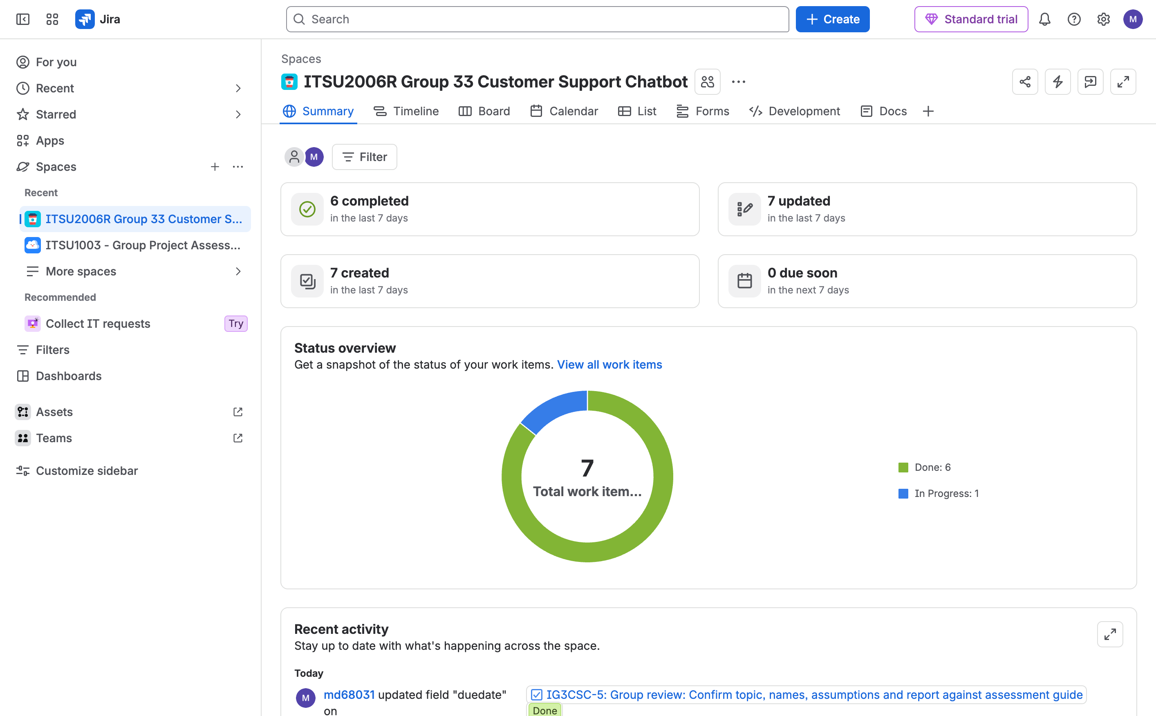
Figure C3: Jira project summary and activity overview.

GitHub repository details
Repository URL: https://github.com/rifathasanrafiii/itsu2006r
Submitted version (commit): ea14038232e6485da4212b81b84c3fdc97e86e63
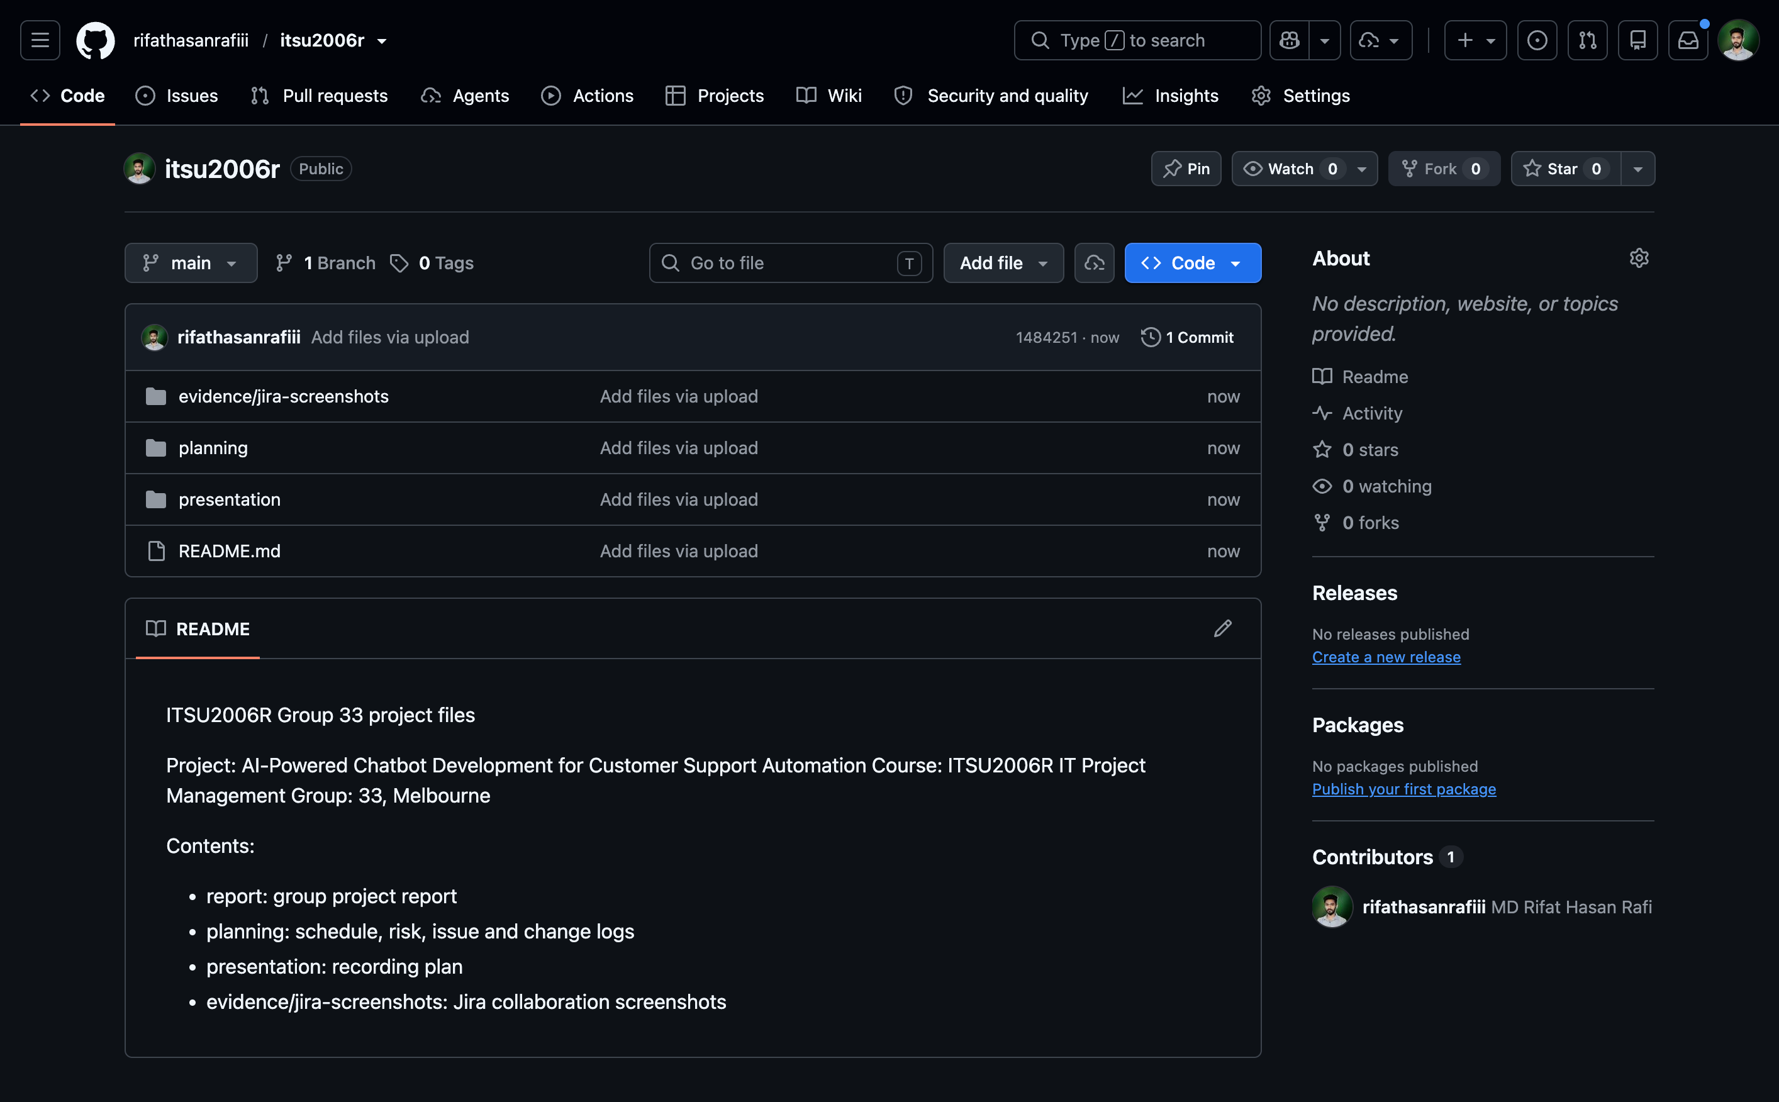
Figure C4: GitHub repository structure and latest commit.

